
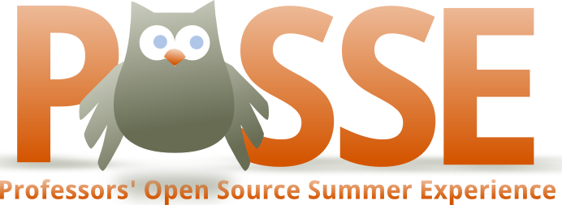

Join Red Hat & Open Source Initiative instructors
for POSSE - a five day workshop
that immerses you in the
open source contribution process
so you can lead your classroom in open participation

06 to 10 July (Tue. to Sat.) 2010
Mountain View, CA

http://teachingopensource.org/index.php/POSSE_California_CS
(http://bit.ly/POSSECALI2010)

Free to attend
Open to anyone teaching students about free/open source software
at universities, colleges, and advanced high schools
Have you considered the benefits of teaching open source participation in the classroom? More than teaching tools and technology, teaching open source is about giving students a chance to get hands on with real code in real situations. A chance to build skills and experiences that scale to fit the classroom.  Professors' Open Source Summer Experience, or POSSE, is a week long class taught by open source community experts from Red Hat and the Open Source Initiative, for those who teach higher education or advanced students in computer science/engineering and electrical engineering (CS, CE, EE.) In this class we teach the skills to be "productively lost" through participation in actual projects. These skills are transferable directly to teaching open source participation in the classroom.  http://teachingopensource.org/index.php/POSSE | We're offering the first California POSSE in Mountain View, 06 to 10 July. If you or someone you know is interested, read more here:  http://teachingopensource.org/index.php/POSSE_California_CS  POSSE itself is free; attendees pay their own travel, lodging, and expenses. To find out more or to apply, check out the program page and send in an application.  If you have questions, our general Teaching Open Source mailing list is used for support, networking, and discussion amongst teaching colleagues and open source experts:  http://teachingopensource.org/mailman/listinfo/tos  You may also email posse@teachingopensource.org for more information.  You are encouraged to pass on this email to anyone or anywhere there might be professors interested in teaching open source.

